*PROJECT REPORT*

*ON*

***FRIEND LECTURE SHARING***

***ACKNOWLEDGEMENT***

*The success and final outcome of this project required a lot of guidance and assistance from many people and we are extremely fortunate to have this all along the completion of our project work. Whatever we have done is only due to such guidance and assistance and I would not forget to thank them.*

*We respect and thank Mr. Parwinder for giving me an opportunity to do the project work on FRIEND LECTURE SHARING and providing us all support and guidance which made us complete the project on time . I am extremely grateful to him for providing such a nice support and guidance though he had busy schedule managing the company affairs.*

*We are thankful to and fortunate enough to get constant encouragement, support and guidance from all Teaching staffs of Department of computer science which helped us in successfully completing our project work. Also, we would like to extend our sincere regards to all the non-teaching staff of department of computer science for their timely support.*

*And last but not the least our team mates without their cooperation we would not have been able to complete the project. So sincere thanks to them for giving a helping hand in completion of our project on time.*

***Contents of the Table:***

***1.Acknowledgement…………….…………….-2***

***2.BrainBite.........................................................-4***

***3.Introduction of Project...................................-4-10***

***4.Software Requirements................................-11-19***

***5.UMD Diagrams…………………………..-20-30***

***6.Screen Shorts…………………………….-30-43***

***8.Conclusion………………………………-44***

***9.Bibliography……………………………..-45***

***FRIEND LECTURE SHARING***

*Brain Bite is a distributed application, developed to Play an online Quiz. It is a software in which we have specified some questions, the participant has to answer for all those questions, some buttons are presented at the bottom of the window like start button , next , finish.*

*When we click the start button the online test get started, you will have to answer 5 questions. If you do not wish to answer a particular question you can move on to next question by pressing next button*

*This software package has been developed using the powerful coding tools of JAVA at Front End and Oracle Sql Server at Back End. The software is very user friendly.*

***Introduction to Project***

*Introduction:*

*Our project Brain Bite is an online quiz application. Its first frame is Login i.e. for Admin or User.User cannot login without userid and password. So he/she first of all do Sign up. Then the Sign Up frame is open. User fill its detailed information. After fillthe form click on the Submit buttonfor submitting the form or click on the Cancel button for not submitting.After clicking the Submit button the Password Field Frame is openedand the user id is assigned to the user.Userid is automatically assigned to the user. Then the user entered its password in the password field and then again entered the password in the confirm password field . If the password field data and the confirm password field data is not matched then a dialog box is shown Password and Confirm Password field is not matched. If it is matched then press the OK button. After Pressing the OK butonthe userid and password is stored inthe database. After thisuser is backon the Login frame. In the login frame first field is userid in this field user entered its own userid number which is unique among all the existing users.Then the second field is Password field , in this field user entered its password. And the next field is Type this is a combo box which has two values first is User and the second is Admin. If logger is User then he/she selects the User value else if he/she is Admin then selects the Admin value. Then the logger click on the login button. Behind the login button an event is occur in this entered userid and password is matched in the database to verify the user is correct or not. If the user is not existed then he/she cannot access this application and the dialog box is shown i.e. Invalid User iflogger is user, or if logger is Admin then shown i.e. Invalid Admin. The Demo button is shown on the frame. If the user is new one and does not know how the quiz isand which type of questions are addedto it then he/she choose this option to play this and identify the quiz application. In this option at least five or six questions are added user can play this and see the result at the end of last question.The user can choose this option without login.*

*If the userid and password of User Loginis matched in the database then the second Home frame is opened in which there is menu bar on the top of the frame. And one of the Category combo box is placed below. Category Combo box has three values first is GK , second is Sports and the last one is Technical. The user can select one value at a time from the category. If he/she selects GK value then the GK question frame is opened. This is an question framewhich is labelled with questions and its four options. User selects only one option among all. Then he/she click on the Next button. Behind the Next button an event is occurred in which the selected option is matched with the correct one from the database. If it is matched then the two marks for correct answer is added to the user score. If it is not matched the one mark is deducted from the user score. And the previous question is replaced with the next questionto the frame. Alsoif the next one is correct the two marks are added and the previous question is replaced with the next one and so on. At the end of the last question the Next button is replaced with the Finish button.After clicking the finish button the Result of session is shown to the user. In the result dialog box it shows the total number of questions, number of correct questions and also shows thetotal score of the user. And add this score to the database for future use.Then the user come back to the Home frame and selects any one category from the category combo box. If again he/she selects the Sports option from the Category combo box. Then the Sports question frame will open. This frame is labelled with only Sports questions and its four options. User selects only one option among all. Then he/she click on the Next button. Behind the Next button an event is occurred in which the selected option is matched with the correct one from the database. If it is matched then the two marks for correct answer is added to the user score. If it is not matched the one mark is deducted from the user score. And the previous question is replaced with the next question to the frame. Also if the next one is correct the two marks are added and the previous question is replaced with the next one and so on. At the end of the last question the Next button is replaced with the Finish button. After clicking the finish button the Result of session is shown to the user. In the result dialog box it shows the total number of questions, number of correct questions and also shows the total score of the user. And add this score to the database for future use. Then again the user come back to the Home frame. If he/she selects the Technical option from the Category combo box. Then the technical question frame will open. This frame is labelled with only technical questions and its four options. User selects only one option among all. Then he/she click on the Next button. Behind the Next button an event is occurred in which the selected option is matched with the correct one from the database. If it is matched then the two marks for correct answer is added to the user score. If it is not matched the one markIs deducted from the user score. And the previous question is replaced with the next question to the frame. Also if the next one is correct the two marks are added and the previous question is replaced with the next one and so on. At the end of the last question the Next button is replaced with the Finish button. After clicking the finish button the Result of session is shown to the user. In the result dialog box it shows the total number of questions, number of correct questions and also shows the total score of the user. And add this score to the database for future use. The score of user is stored according to its category. If the user played the GK quiz then the score of this category is stored in GK field in the database of the user. If the user played the SPORTS quiz then the score of this category is stored in SPORTS field in the database of the user. And if the user played the TECHNICAL quiz then the score of this category is stored in TECHNICAL field in the database of the user. The working of the second menu i.e. Setting is used by user to view the report of him/her in the application, he/she can update his password and also view his own general information. The third menu i.e. About us shows the information about Brain Bite application and information about developers.*

*IF Admin want to access this application. He/She can logged by the Login frame. In this fame, Admin entered its admin id in the user id field, entered the password in the password field and selects the Admin type from the Type combo box. Then click on the Login button. Behind the login button an event is occurred i.e. it match the entered user id field and entered password field with the existing admin id and password fields from the AdminLogin table from the database. If it is matched then the admin go to the Admin Panel frame. In this frame admin view its rights. Because admin is the only person who can manage this application. This frame consists of labels and some buttons. The Hello Admin label is shown on the top and three consecutive buttons first is Questions, second is Users and the third one is Admin. When the admin clicks the Question button then an event is occurred on the mouse click and the new Question queries frame will opened. This question queries frame also a collection of some labels, one combo box and some buttons the first label is Question Point!!! Then the combo box is placed it is used to selects the category to performs queries like ADD, VIEW, UPDATE and DELETE on selected category. If the admin select the GK option from the combo box then click on ADD button, the new Add question frame is opened to add the new GK question. In this frame first field is Question the admin can entered the question into this field, the second field is option A the admin can enters the first option in this field, the third field is option B the admin can enters the second option in this field, the fourth field is option C field the admin can enters the third option in this field, the fifth field is option D the admin can enters the fourth option in this field and the last one is correct answer field in which the admin can enters the correct option in this field. The Submit button is placed at last. When the admin enters the values in the frame then he/she click on the Submit button. When the admin click on Submit button then the entered field’s data is stored into the GKQ table into the database. If admin wants to view the GK questions then he/she click on the VIEW button in question queries frame. In this frame admin views all the questions of GK category. If admin clicks on the UPDATE button in the question queries frame then a new frame is opened to update the selected question. In this frame first of all admin selects the question, enters the new value to the selected question and then click on the UPDATE button to update the question. If the admin wants to delete a question then admin click on the DELETE button in the question queries frame, after clicking a delete frame is opened firstly admin enters the qid i.e. question id to the Enter question id field then click on the DELETE button to delete the question. If the user selects the Sports category then click on ADD button in the question queries frame to add new sports question in the sports question database. The new Add question frame is opened to add the new Sports question. In this frame first field is Question the admin can entered the question into this field, the second field is option A the admin can enters the first option in this field, the third field is option B the admin can enters the second option in this field, the fourth field is option C field the admin can enters the third option in this field, the fifth field is option D the admin can enters the fourth option in this field and the last one is correct answer field in which the admin can enters the correct option in this field. The Submit button is placed at last. When the admin enters the values in the frame then he/she click on the Submit button. When the admin click on Submit button then the entered field’s data is stored into the SPORTSQ table into the database. If admin wants to view the SPORTS questions then he/she click on the VIEW button in question queries frame. In this frame admin views all the questions of SPORTS category. If admin clicks on the UPDATE button in the question queries frame then a new frame is opened to update the selected question. In this frame first of all admin selects the question, enters the new value to the selected question and then click on the UPDATE button to update the question. If the admin wants to delete a question then admin click on the DELETE button in the question queries frame, after clicking a delete frame is opened firstly admin enters the qid i.e. question id to the Enter question id field then click on the DELETE button to delete the question. If the admin selects the TECHNICAL category from the question queries frame then clicks the ADD button to add the new TECHNICAL questions then the new ADD TECHNICAL question frame is opened . In this frame first field is Question the admin can entered the question into this field, the second field is option A the admin can enters the first option in this field, the third field is option B the admin can enters the second option in this field, the fourth field is option C field the admin can enters the third option in this field, the fifth field is option D the admin can enters the fourth option in this field and the last one is correct answer field in which the admin can enters the correct option in this field. The Submit button is placed at last. When the admin enters the values in the frame then he/she click on the Submit button. When the admin click on Submit button then the entered field’s data is stored into the TECHNICALQ table into the database. If admin wants to view the TECHNICAL questions then he/she click on the VIEW button in question queries frame. In this frame admin views all the questions of TECHNICAL category. If admin clicks on the UPDATE button in the question queries frame then a new frame is opened to update the selected question. In this frame first of all admin selects the question, enters the new value to the selected question and then click on the UPDATE button to update the question. If the admin wants to delete a question then admin click on the DELETE button in the question queries frame, after clicking a delete frame is opened firstly admin enters the qid i.e. question id to the Enter question id field then click on the DELETE button to delete the question.*

*If the admin clicks on the Users button in the Admin Panel then the admin view all the users of the application. The admin can delete those users who cannot accessed his account from two months. The admin can deactivate the account of these users. Admin button in the Admin Panel if admin click on this then the new Admin Queries frame will open. This frame consists of four consecutive buttons. When the admin clicks on the ADD panel then the Add Admin frame will open. In this frame the first field is Admin id the new admin can enters the admin id , enters the Password and enters the password again in Confirm Password field. Then click on the OK button if the password field data and the confirm password data is not match then a dialog box is shown i.e. Mismatch data between the password and the confirm password field. If the Password and the Confirm Password field is matched then the entered data in fields are stored in the Admin Login table in tdahe database. If admin wants to view all the existing admins then he/she clicks on the VIEW button in the Admin queries frame. When the admin clicks on the UPDATE button then the update panel is open to update the password of the existing admin. If the admin click on the Delete button in the admin queries then delete panel will be opened to delete the existing admin. In this admin queries frame admin can ADD , DELETE , UPDATE , VIEW by the existing admin.*

***OBJECTIVES OF THE PROJECT:***

*This concept of online test fulfils the following requirements:*

* *It provides a less expensive as well as an effective method of performing examinations.*
* *It provides best facilities for the students to answer the question only with a single click.*
* *It saves time as well as money.*
* *It lessens the student’s and teacher’s frustration.*
  1. *AREAS OF APPLICATION*
* ***Across the globe****: This project finds it application in conducting examination over the globe.*
* ***Student’s needs****: It saves time as well as money. It lessens student’s frustration.*

***FEASIBILITY STUDY:***

*Feasibility study defines all the requirements to performance characteristics of system.For system to be feasible, the design needs to undertake various factors or performance requirements by which the system will be operated.*

*A feasibility study is short, focused study which aims at selecting the best system that meets performance requirements. Information is gathered regarding the general requirements of the proposed system.*

*If feasibility study is to serve as the decision document, it answers a number of questions.*

*Like*

* *Is it beneficial?*
* *Does it save time and money?*
* *Can it be integrated with other systems already in place?*

*Planning resources is a very vast concept and we are beginners, thus including each and every aspects of web, Integrate and automate them in every respect was not feasible for us.Hence we perform feasibility study to make our project compatible for present environment. The concept of Online Testis newer. The project is built with the help of* ***JAVA*** *technology which is reliable and efficient platform to work upon. This concept saves time and lessens the teacher’s and student’s frustration.*

***Technical feasibility***

*Technical feasibility takes of the all the issues concerned with the design and the development part of the project. It concerns itself with the software, hardware and the platform related issues. The following are the technical specifications for our project.*

*The project would require a lot of space for storage of static as well as dynamic content.*

*As the number of project available increases the space required for storing them increases.*

***Economic feasibility***

* *It provides an efficient and reliable platform to work upon.*
* *It saves time and is thus a faster means of examination.*
* *It is less costly than the other means of examination.*

***Software Requirements***

***Front End: Java***

***Back End: MY SQL WORKBENCH***

***ABOUT JAVA***

*Java technology is both a programming language and a platform.*

### *The Java Programming Language*

*The Java programming language is a high-level language that can be characterized by all of the following buzzwords:*

|  |  |
| --- | --- |
| * *Simple* | * *Architecture neutral* |
| * *Object oriented* | * *Portable* |
| * *Distributed* | * *High performance* |
| * *Multithreaded* | * *Robust* |
| * *Dynamic* | * *Secure* |

*Each of the preceding buzzwords is explained in* [*The Java Language Environment*](http://java.sun.com/docs/white/langenv/) *, a white paper written by James Gosling and Henry Mc Galton. In the Java programming language, all source code is first written in plain text files ending with the .java extension. Those source files are then compiled into .class files by the javac compiler. A .class file does not contain code that is native to your processor; it instead contains byte codes — the machine language of the Java Virtual Machine*[*1*](http://java.sun.com/docs/books/tutorial/getStarted/intro/definition.html) *(Java VM). The java launcher tool then runs your application with an instance of the Java Virtual Machine.*

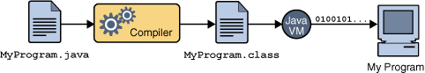

* *An overview of the software development process.*

*Because the Java VM is available on many different operating systems, the same .class files are capable of running on Microsoft Windows, the Solaris TM Operating System (Solaris OS), Linux, or Mac OS. Some virtual machines, such as the* [*Java HotSpot virtual machine*](http://java.sun.com/products/hotspot/)*, perform additional steps at runtime to give your application a performance boost. This include various tasks such as finding performance bottlenecks and recompiling (to native code) frequently used sections of code.*

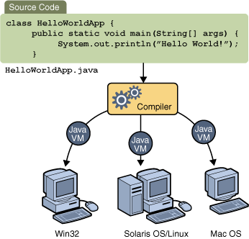

*Through the Java VM, the same application is capable of running on multiple platforms.*

### *The Java Platform*

*A platform is the hardware or software environment in which a program runs. We've already mentioned some of the most popular platforms like Microsoft Windows, Linux, Solaris OS, and Mac OS. Most platforms can be described as a combination of the operating system and underlying hardware. The Java platform differs from most other platforms in that it's a software-only platform that runs on top of other hardware-based platforms.*

*The Java platform has two components:*

*• The Java Virtual Machine*

*• The Java Application Programming Interface (API)*

*The general-purpose, high-level Java programming language is a powerful software platform. Every full implementation of the Java platform gives you the following features:*

*•* ***Development Tools:*** *The development tools provide everything you'll need for compiling, running, monitoring, debugging, and documenting your applications. As a new developer, the main tools you'll be using are the javac compiler, the java launcher, and the java doc documentation tool.*

*•* ***Application Programming Interface (API):*** *The API provides the core functionality of the Java programming language. It offers a wide array of useful classes ready for use in your own applications. It spans everything from basic objects, to networking and security, to XML generation and database access, and more. The core API is very large; to get an overview of what it contains, consult the* [*Java SE Development Kit 6 (JDKTM 6) documentation*](http://java.sun.com/javase/6/docs/index.html)*.*

*•* ***Deployment Technologies****: The JDK software provides standard mechanisms such as the Java Web Start software and Java Plug-In software for deploying your applications to end users.*

*•* ***User Interface Toolkits****: The Swing and Java 2D toolkits make it possible to create sophisticated Graphical User Interfaces (GUIs).*

*     •* ***Integration Libraries****: Integration libraries such as the Java IDL API, TM API, Java Naming and Directory InterfaceTM ("J.N.D.I.") API, Java RMI, and Java Remote Method Invocation over Internet Inter-ORB Protocol Technology (Java RMI-IIOP Technology) enable database access and manipulation of remote objects.*

## Why Java's a Better Programming Language

*If that were all Java was, it would still be more interesting than a <marquee> or <frame> tag in some new browser beta, but there's a lot more. Java isn't just for web sites. Java is a programming language that can do almost anything a traditional programming language like FORTRAN, Basic or C++ can do. However Java has learned from the mistakes of its predecessors. It is considerably easier to program and to learn than those languages without giving up any of their power.*

*The Java language shares many superficial similarities with C, C++, and Objective C. For instance, loops have identical syntax in all four languages, However, Java is not based on any of these languages, nor have efforts been made to make it compatible with them.*

*Java is sometimes referred to as C++++--. James Gosling invented Java because C++ proved inadequate for certain tasks. Since Java's designers were not burdened with compatibility with existing languages, they were able to learn from the experience and mistakes of previous object-oriented languages. They added a few things C++ doesn't have like garbage collection and multithreading (the ++) and they threw away C++ features that had proven to be better in theory than in practice like multiple inheritance and operator overloading (the --). A few advanced features like closures and parameterized types that the Java team liked were nonetheless left out of the language due to time constraints. There's still argument over whether the right choices were made. Parameterized types (templates to C++ programmers) may be added in a later revision of Java.*

*Java has learned a lot from previous languages. Let's look at some of the advantages Java offers programmers.*

### *Java is Simple*

*Java was designed to make it much easier to write bug free code. According to Sun's Bill Joy, shipping C code has, on average, one bug per 55 lines of code. The most important part of helping programmers write bug-free code is keeping the language simple.*

*Java has the bare bones functionality needed to implement its rich feature set. It does not add lots of syntactic sugar or unnecessary features. The language specification for Java is only about eighty pages long compared to a couple of hundred pages for C and even more for C++. Despite its simplicity Java has considerably more functionality than C.*

*Because Java is simple, it is easy to read and write. Obfuscated Java isn't nearly as common as obfuscated C. There aren't a lot of special cases or tricks that will confuse beginners.*

*About half of the bugs in C and C++ programs are related to memory allocation and de allocation. Therefore the second important addition Java makes to providing bug-free code is automatic memory allocation and de allocation. The C library memory allocation functions malloc() and free() are gone as are C++'s destructors.*

*Java is an excellent teaching language, and an excellent choice with which to learn programming. The language is small so it's easy to become fluent in it. The language is interpreted so the compile-link-run cycle is much shorter. (In fact, the link phase is eliminated entirely.) The runtime environment provides automatic memory allocation and garbage collection so there's less for the programmer to think about. Java is object-oriented (unlike Basic) so the beginning programmer doesn't have to unlearn bad programming habits when moving into real world projects. Finally, it's very difficult (if not quite impossible) to write a Java program that will crash your system, something that you can't say about any other language.*

### *Java is Object-Oriented*

*Object oriented programming was the catch phrase of computer programming in the 1990's. Although object oriented programming has been around in one form or another since the Simulate language was invented in the 1960's, it really took hold in modern GUI environments like Windows, Motif and the Mac. In object-oriented programs data is represented by objects. Objects have two sections, fields (instance variables) and methods. Fields tell you what an object is. Methods tell you what an object does. These fields and methods are closely tied to the object's real world characteristics and behavior. When a program runs messages are passed back and forth between objects. When an object receives a message, it responds accordingly as defined by its methods.*

*Object oriented programming is alleged to have a number of advantages including:*

* *Simpler, easier to read programs*
* *More efficient reuse of code*
* *Faster time to market*
* *More robust, error-free code*

*In practice object-oriented programs have been just as slow, expensive and buggy as traditional non-object-oriented programs. In large part this is because the most popular object-oriented language is C++. C++ is a complex, difficult language that shares all the obfuscation of C while sharing none of C's efficiencies. It is possible in practice to write clean, easy-to-read Java code. In C++ this is almost unheard of outside of programming textbooks.*

### *Java is Platform Independent*

*Java was designed to not only be cross-platform in source form like C, but also in compiled binary form. Since this is frankly impossible across processor architectures, Java is compiled to an intermediate form called byte-code.*

*A Java program never really executes natively on the host machine. Rather a special native program called the Java interpreter reads the byte code and executes the corresponding native machine instructions. Thus to port Java programs to a new platform, all you need to do is run it with an interpreter written for the new platform. You don't even need to recompile. Even the compiler is written in Java. The byte codes are precisely defined, and remain the same on all platforms.*

*The second important part of Java's cross-platform savvy is the elimination of undefined and architecture dependent constructs. Integers are always four bytes long, and floating point variables follow the IEEE 754 standard for computer arithmetic exactly. You don't have to worry that the meaning of an integer is going to change if you move from a Pentium to a PowerPC. In Java everything is guaranteed.*

*However the virtual machine itself and some parts of the class library must be written in native code. These are not always as easy or as quick to port as pure Java programs. This is why for example, there's not yet a version of Java 1.2 for the Mac.*

### *Java is Safe*

*Java was designed from the ground up to allow for secure execution of code across a network, even when the source of that code was untrusted and possibly malicious.*

*This required the elimination of many features of C and C++. Most notably there are no pointers in Java. Java programs cannot access arbitrary addresses in memory. All memory access is handled behind the scenes by the (presumably) trusted runtime environment. Furthermore Java has strong typing. Variables must be declared, and variables do not change types when you aren't looking. Casts are strictly limited to casts between types that make sense. Thus you can cast an int to a long or a byte to a short but not a long to a Boolean or an int to a String.*

*Java implements a robust exception handling mechanism to deal with both expected and unexpected errors. The worst that a Java program can do to a host system is bringing down the runtime environment. It cannot bring down the entire system.*

*Most importantly Java applets can be executed in an environment that prohibits them from introducing viruses, deleting or modifying files, or otherwise destroying data and crashing the host computer. A Java enabled web browser checks the byte codes of an applet to verify that it doesn't do anything nasty before it will run the applet.*

*However the biggest security problem is not hackers. It's not viruses. It's not Visual Basic worms transmitted by Outlook Express. It's not even insiders erasing their hard drives and quitting your company to go to work for your competitors. No, the biggest security issue in computing today is* ***bugs****. Regular, ordinary, non-malicious, unintended bugs are responsible for more data loss and lost productivity than all other factors combined. Java, by making it easier to write bug-free code, substantially improves the security of all kinds of programs.*

### *Java is High Performance*

*Java byte codes can be compiled on the fly to code that rivals C++ in speed using a "just-in-time compiler." Several companies are also working on native-machine-architecture compilers for Java. These will produce executable code that does not require a separate interpreter, and that is indistinguishable in speed from C++. While you'll never get that last ounce of speed out of a Java program that you might be able to wring from C or FORTRAN, the results will be suitable for all but the most demanding applications.*

*As of May, 1999, the fastest VM, IBM's Java 1.1 VM for Windows, is very close to C++ on CPU-intensive operations that don't involve a lot of disk I/O or GUI work; C++ is itself only a few percent slower than C or FORTRAN on CPU intensive operations.*

*It is certainly possible to write large programs in Java. The Hot Java web browser, the JBuilder integrated development environment and the javac compiler are large programs that are written entirely in Java.*

### *Java is Multi-Threaded*

*Java is inherently multi-threaded. A single Java program can have many different processes executing independently and continuously. Three Java applets on the same page can run simultaneously with each getting equal time from the CPU with very little extra effort on the part of the programmer. This makes Java incredibly responsive to user input. It also helps to contribute to Java's robustness and provides a mechanism whereby the Java environment can ensure that a malicious applet doesn't steal all of the host's CPU cycles.*

*Unfortunately multithreading is so tightly integrated with Java, that it makes Java rather difficult to port to architectures like Windows 3.1 or the PowerMac that don't natively support preemptive multi-threading.*

*There is another cost associated with multi-threading. Multi-threading is to Java what pointer arithmetic is to C; that is, a source of devilishly hard to find bugs. Nonetheless, in simple programs it's possible to leave multi-threading alone and normally be OK.*

### *Java is Dynamically( linked)*

*Java does not have an explicit link phase. Java source code is divided into .java files, roughly one per each class in your program. The compiler compiles these into .class files containing byte code. Each .java file generally produces exactly one .class file. (There are a few exceptions we'll discuss later, non-public classes and inner classes).*

*The compiler searches the current directory and a few other well specified places to find other classes explicitly referenced by name in each source code file. If the file you're compiling depends on other, non-compiled files, then the compiler will try to find them and compile them as well. The Java compiler is quite smart, and can handle circular dependencies as well as methods that are used before they're declared. It also can determine whether a source code file has changed since the last time it was compiled.*

*More importantly, classes that were unknown to a program when it was compiled can still be loaded into it at runtime. For example, a web browser can load applets of differing classes that it's never seen before without recompilation.*

*Furthermore, Java .class files tend to be quite small, a few kilobytes at most. It is not necessary to link in large runtime libraries to produce an executable. Instead the necessary classes are loaded from the user's local system.*

### *Java is Garbage Collected*

*You do not need to explicitly allocate or de allocate memory in Java. Memory is allocated as needed, both on the stack and the heap, and reclaimed by the garbage collector when it is no longer needed. There are no malloc(), free(), or destructor methods. There are constructors and these do allocate memory on the heap, but this is transparent to the programmer.*

*Most Java virtual machines use an inefficient, mark and sweep garbage collector. Some more recent virtual machines have improved matters quite a bit by using generational garbage collection.*

*To sum up, Java is a safe, robust, garbage-collected, object-oriented, high-performance, multi-threaded, interpreted, architecture-neutral, cross-platform, buzzword-compliant programming language*

***Swing***

*Swing is not an acronym. It packages a set of GUI components. Unlike AWT components, that are associated to native screen resources (heavyweight), Swing components draw themselves on the screen (lightweight). This results in slower execution but a Swing application will look the same on all platforms. Because Swing supports pluggable look-and-feel, you could have a Windows look in your Unix environment (if you would ever want that). Check out the numerous subcategories for code examples for each component.*

*Swing is the primary Java GUI widget Tool Kit. It is part of Oracle's Java Foundation Classes (JFC) — an API for providing a Graphical User Interface (GUI) for Java programs.*

*Swing was developed to provide a more sophisticated set of GUI components than the earlier Abstract Window Toolkit. Swing provides a native look and feel that emulates the look and feel of several platforms, and also supports a plug able look and feel that allows applications to have a look and feel unrelated to the underlying platform. It has more powerful and flexible components than AWT. In addition to familiar components such as buttons, check boxes and labels, Swing provides several advanced components such as tabbed panel, scroll panes, trees, tables, and lists.*

*Unlike AWT components, Swing components are not implemented by platform-specific code. Instead they are written entirely in Java and therefore are platform-independent. The term "lightweight" is used to describe such an element.*

***Subcategories:***

* ***javax.swing.border.***
* ***javax.swing.text.***
* ***javax.swing.undo.***
* ***JComponent***
* ***Top-Level Containers(JApplet,JDialog,JOptionPane,JFrame)***
* ***General-Purpose Containers(JPanel,JScrollPane,JSplitPane,JTabbedPane,***

***JToolBar)***

* ***Special-Purpose Containers(JDesktop,JInternalFrame,JLayredPane,***

***JRootPane)***

* ***Atomic Controls(JButton,JCheckBox,JRadioButton,JComboBox,***

***JList,JMenu,JSlider,JTextFied)***

* ***UneditableAtomatic Controls(JLabel,JProgressBar,JToolTip)***
* ***Editable atomic Controls(JColorChooser,JfileChooser,***

***JTableJTextArea,JEditorPane,JTree)***

* ***HTMLEditorKit***
* ***RTFEditorKit***
* ***SwingEvents***
* ***SwingLookand Feel***

***Back End: Oracle 10g***

*Oracle10g is the latest version of the Oracle*

* *DBMS, released early 2004*
* *One of the main focus of that release was self management*

*– Effort initiated in Oracle9i*

* *Our vision when we started this venture four*

*years ago: make Oracle fully self-manageable*

* *We believe Oracle10g is a giant step toward this goal*

***UML DIAGRAMS:***

Class Name

static Connection connection

static Statement stmt

+ public static String sql

DbcPassword

Class Name Data Members

+public static void driverManager()

+ public static Connection getConnection()

+ public static Statement getStatement()

+ public static void closeConnection()

Member Functions

DemoEx

Class Name

-private static final long serialVersionUID

+int marks

Data Members

+public DemoEx

+public void actionPerformed(ActionEvent a)

Member Functio Member Functions

UserPassword

+ public UserPassword

+public void actionPerformed(ActionEvent ae)

+ int usrid

+ int st

+ JtextField txtcnf

Class Member

Data Member

Member Functions

Mainframe

Class Name

+ Jbutton log

+ JtextField txtuserid

+ Jpassword txtPassword

String query

Data Member

+public void actionPerformed(ActionEvent ae)

+public static void main(String [] args)

Member Function

+ public MenuFrame

+ public void actionPerformed

+ JcomboBox combo

+ JMenuBar menubar,menuSetting,menuAbout

+ JMenuItem itemAdmin,itemGeneral,itemView,

itemReport

+ JMenu menuUser

MenuFrame

Class Name

Data Members

Member Functions

+ public UserInformation

+public void actionPerformed

UserInformation

+ String ge

+ JLabel firstname,middlename,lastnamequalification,gender,dOB,lblpincode,lblEmail,lblcontact

+ JTextField txtfirstName,txtMiddleName,txtLastName,txtdOB,txtPinCode,txtEmail

+ JRadioButton rdbtmale,rdbtfemale

+ JLabel qname,qa,qb,qc,qd,qans

+ JTextArea tqname

+ JTextField tqa,tqb,tqc,tqd,tqans

+ JPanel p,bt,sql

+ ResultSet rs

+public AddQuestionGK

+public void actionPerformed

+ JLabel qname,qa,qb,qc,qd,qans

+ JTextArea tqname

+ JTextField tqa,tqb,tqc,tqd,tqans

+ JPanel p,bt,sql

+ ResultSet rs

AddQuestionGK

+public AddQuestionDemo

+public void actionPerformed

AddQuestionDemo

+public AddQuestionTechnical

+public void actionPerformed

+ JLabel qname,qa,qb,qc,qd,qans

+ JTextArea Tqname

+ JTextField tqq,tqb,tqc,tqd,tqans

+ JPanel p,bt,sql

+ ResultSet rs

AddQuestionTechnical

+public AddQuestionSports

+public void actionPerformed

+ JLabel qname,qa,qb,qc,qd,qans

+ JTextArea Tqname

+ JTextField tqq,tqb,tqc,tqd,tqans

+ JPanel p,bt,sql

+ ResultSet rs

AddQuestionSports

+public QuestionFrameGK

+public void actionPerformed

+ JLabel jlQNo,jlQNam

+ JButton btnxt,btfini

+ ButtonGroup btgr

+ JRadioButton ra,rb,rc,rd

+ Int no,qid,marks

QuestionFrameGK

+public QuestionFrameDemo

+public void actionPerformed

+ JLabel jlQNo,jlQNam

+ JButton btnxt,btfini

+ ButtonGroup btgr

+ JRadioButton ra,rb,rc,rd

+ Int no,qid

QuestionFrameDemo

+public QuestionFrameTechnical

+public void actionPerformed

+ JLabel jlQNo,jlQNam

+ JButton btnxt,btfini

+ ButtonGroup btgr

+ JRadioButton ra,rb,rc,rd

+ Int no,qid,marks

QuestionFrameTechnical

+public QuestionFrameSports

+public void actionPerformed

+ JLabel jlQNo,jlQNam

+ JButton btnxt,btfini

+ ButtonGroup btgr

+ JRadioButton ra,rb,rc,rd

+ Int no,qid,marks

QuestionFrameSports

+public AddAdmin

+ public actionPerformed

+ JLabel jlAdmin,jlPass,jlCnfpass

+ JTextField txtadmin

+ JPasswordField txtPass,txtCnfPass

+ JButton btCancel

+ JPanel p

AddAdmin

+public AboutUs

+ JFrame jf

+ JPanel pan,pan0,pan1,pan2,

+ JPanel pan3,pan4,

+JPanel pan5,pan6,pan7,pan8,pan9

+JLabel jb,jb0,jb1,jb2,jb3,jb4,jb5,jb6

+ JLabel jb7,jb8,jb9

AboutUs

+public BriefQuestion

+ public actionPerformed

+ JLabel lblComnt

+ JButton ques,users,admin,delete

+ JComboBox combo

BriefQuestion

+public AdminLogin

+ public actionPerformed

+ JLabel jlLog,jlPass

+ JTextField txtLog,txtPass

+ JButton btLog,btCancel

+ JPanel p

AdminLogin

***SCREEN SHORTS:***

***About Us: Panel and Login***

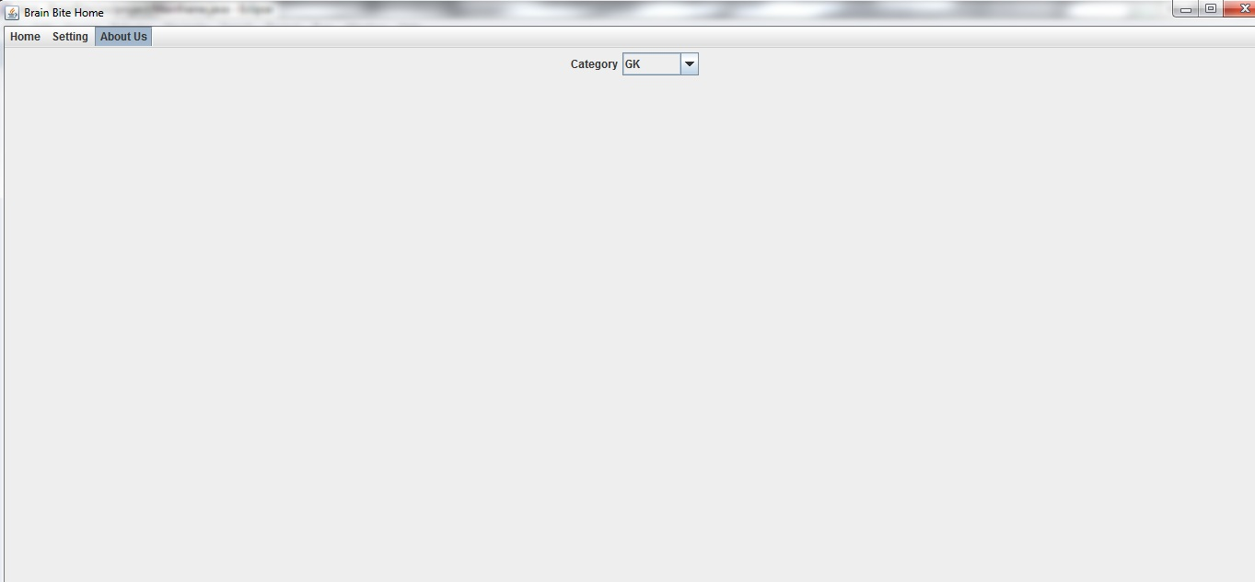

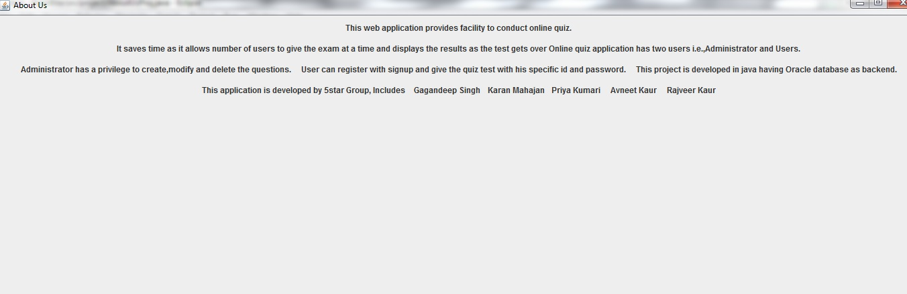

***Add Admin:***

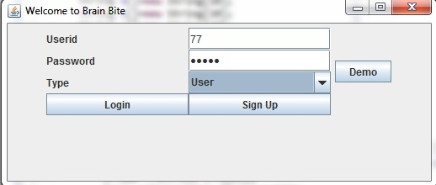

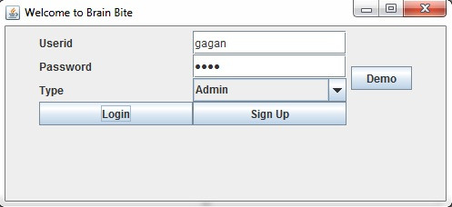

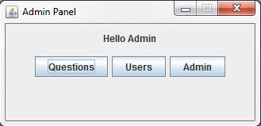

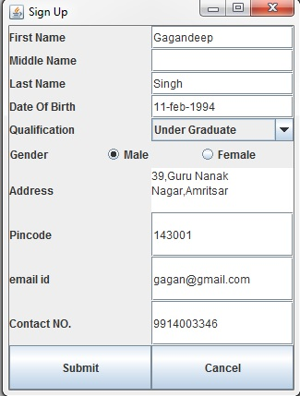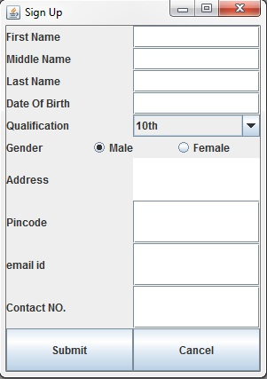

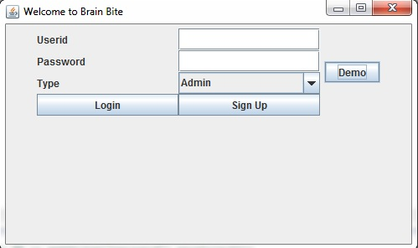

***AddQuestionDemo:***

***DemoQue1-***

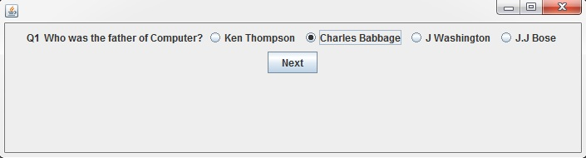

***QueDemo-2***

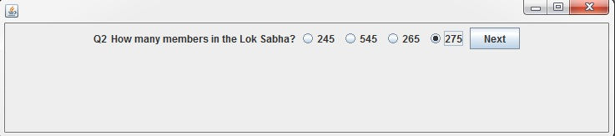

***QueDemo-3***

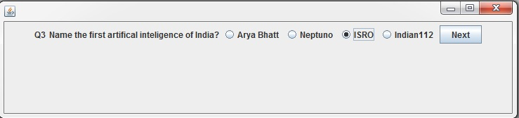

***QueDemo-4***

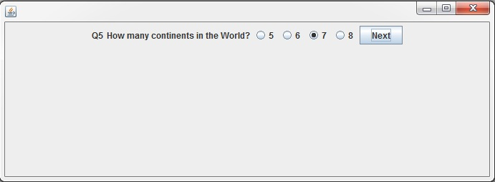

***QueDemo -5 and Result:***

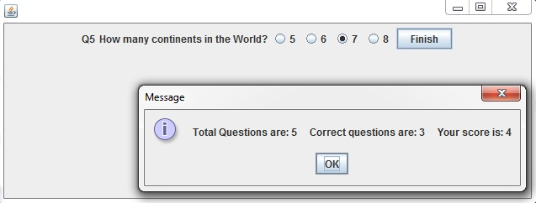

***AddQuestionGk:***

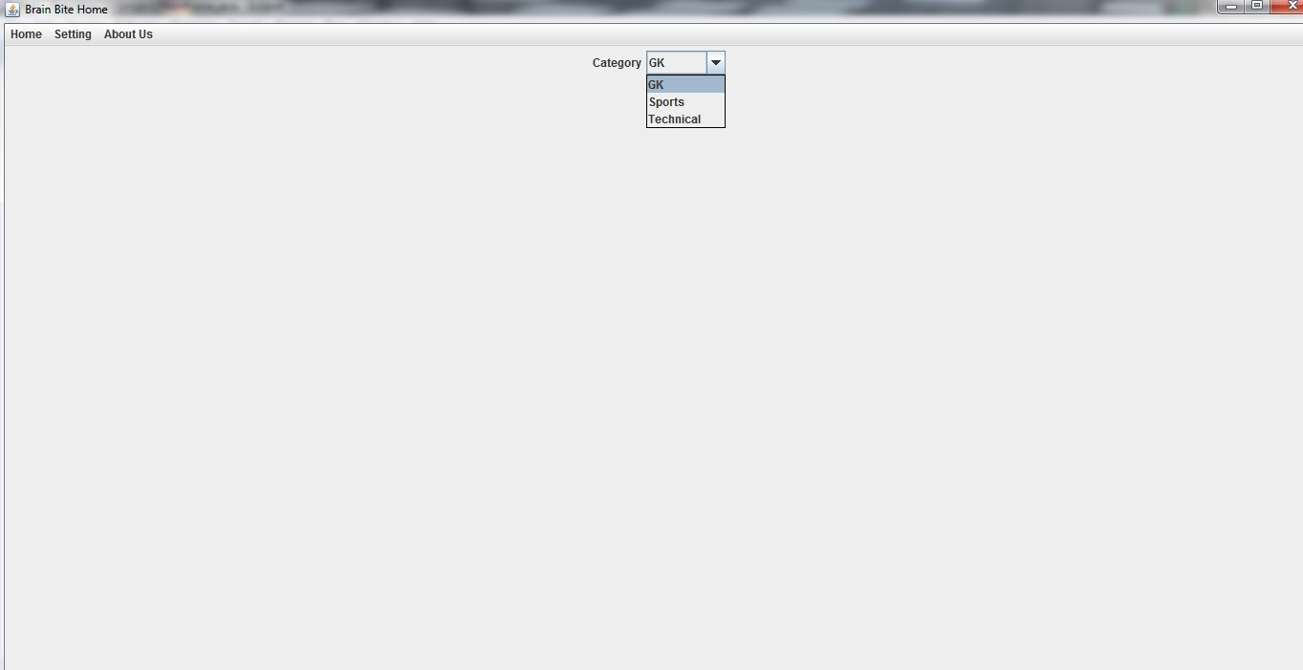

***Que-1***

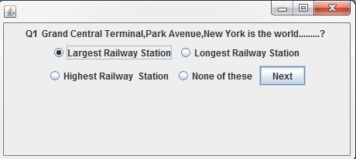

***Que-2***

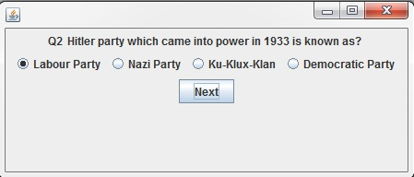

***Que-3***

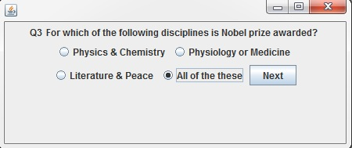

***Que-4***

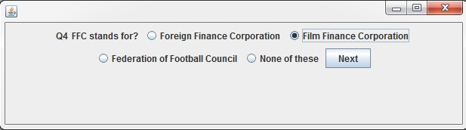

***Que-5***

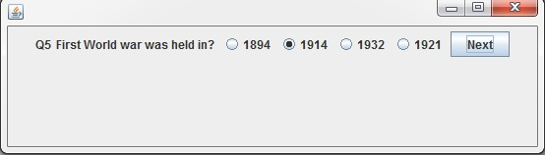

***Result-***

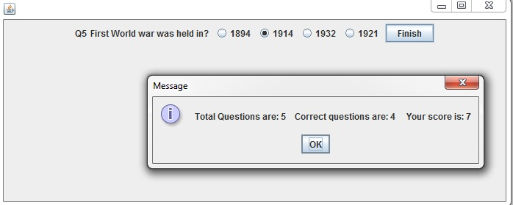

***AddQuestionSports:***

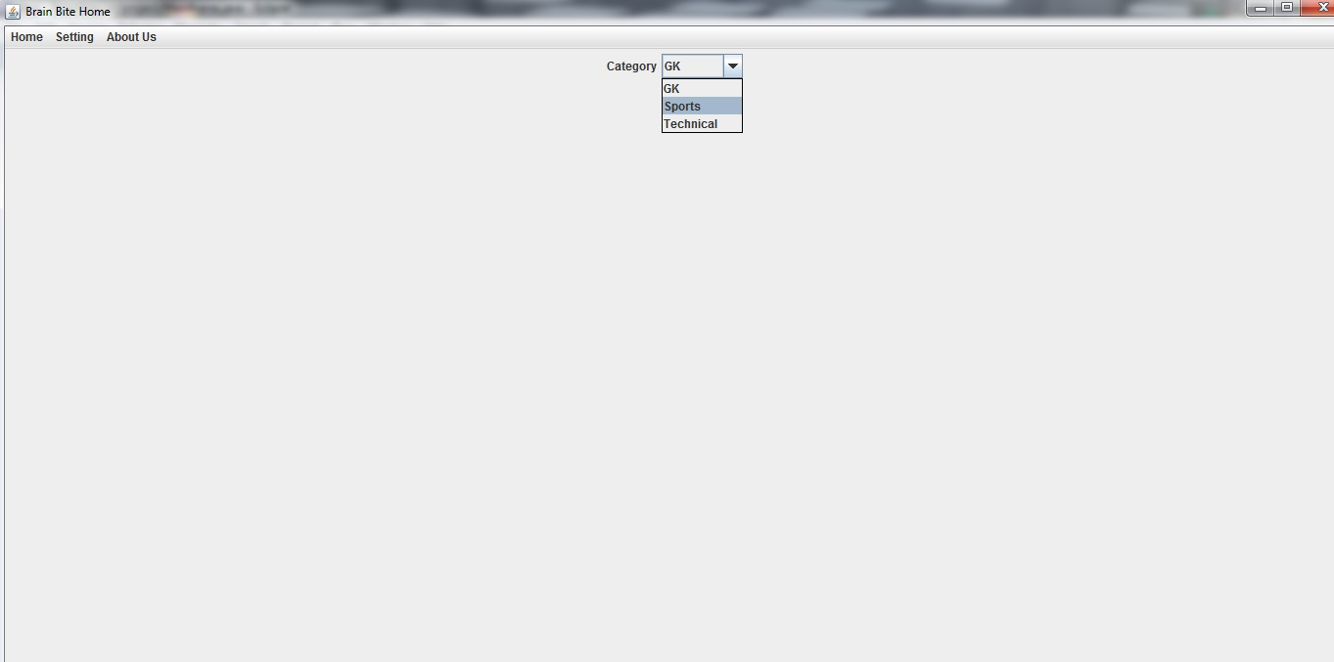

***Que-1***

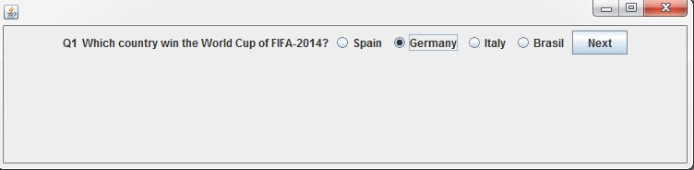

***Que-2***

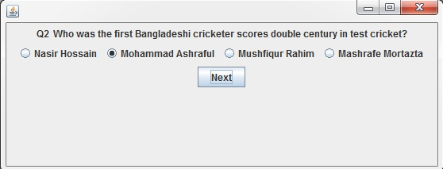

***Que-3***

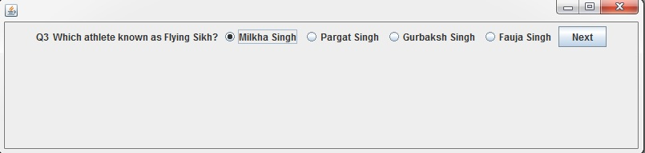

***Que-4***

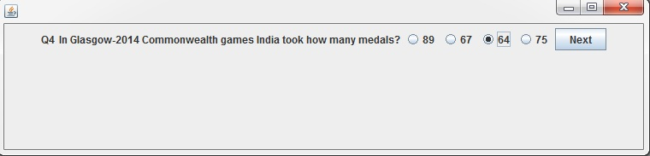

***Que-5***

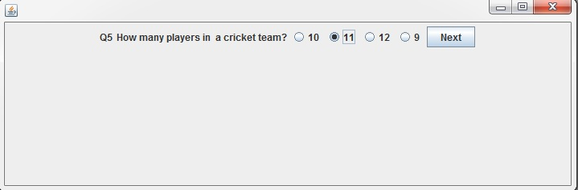

***Result-***

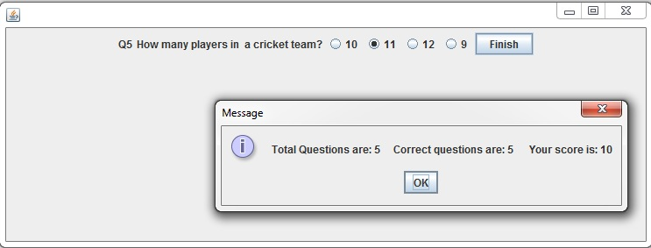

***AddQuestionSports-***

***Que-1***

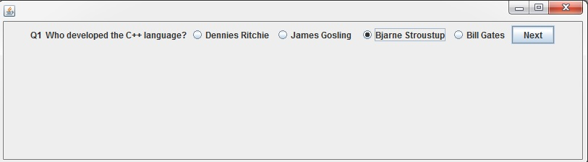

***Que-2***

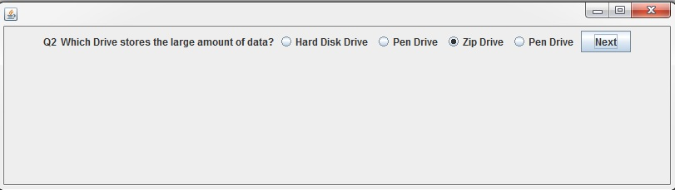

***Que-3***

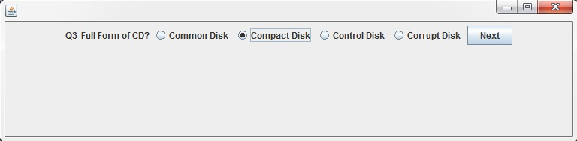

***Que-4***

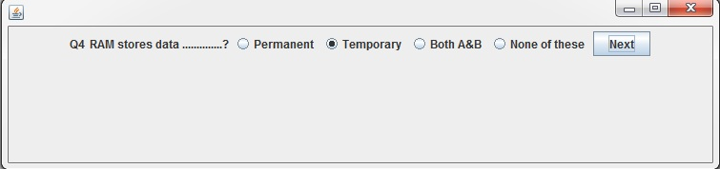

***Que-5***

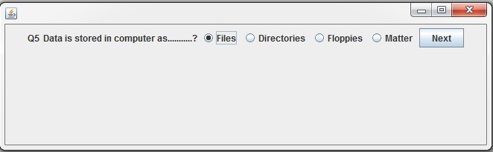

***Que-6***

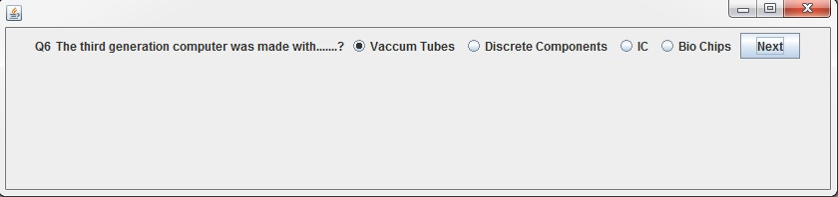

***Result-***

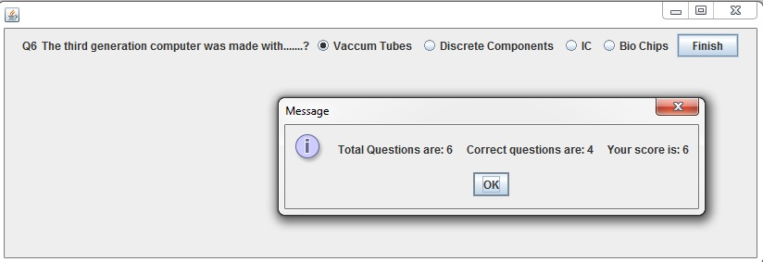

***CONCLUSION-***

***The On line test System is developed using Java and sql fully meets the objectives of the system for which it has been developed. The system has reached a steady state where all bugs have been eliminated. The system is operated at a high level of efficiency and all the teachers and user associated with the system understands its advantage. The system solves the problem. It was intended to solve as requirement specification.***

***Bibliography:***

**Bibliography**

1. Java Server programming .
2. Google.
3. Our Team mates.

**Future Scope**

Scope of this project is very broad in terms of other manually taking exams. Few of them are:-

This can be used in educational institutions as well as in corporate world.

Can be used anywhere any time as it is a web based application(user location doesn’t matter).

No restriction that examiner has to be present when the candidate takes the test

.